Forensics CA2

Task 1:

- To start up the steps to initialise an virtual machine using virtual box as the application of choice to do so all you need is to download virtual box firstly. Then all you need to do is create a new VM using the new button in the top left of the application. Then fill in the details however you like for this example though I would recommend using ubuntu the latest version and to accomplish this goal you will need to download an iso image of an ubuntu machine on their website you can just google this and it will com up all on its own. Then one that is all done and the whole set up of the VM. Make sure the network settings and that no information can be shared between the host machine and the VM as this would cause issues if the malware could escape outside of the sandbox so make sure the network interfaces are disabled. Next add the ram capture to the VM this could be done a number of ways. The next step I would recommend is downloading the software volatility which is used to analyse the RAM capture and this can be used to find the malware. The next steps would be to document all that you find and use the relevant volatility commands to attempt to identify if there is any malware on this machine.

- The configuration of the Vm should be that the host machine and the VM have no access to be able to communicate with each other for example the network config of the VM all the interfaces should be disabled or not allocated for this example. Also the following should also be disabled such as guest additions, folder sharing, cut and paste and any other sharing features between the VM and the host machine. This would allow the malware to stay on the VM and not allow it to jump ship and reach the host machine

- Advantages: VM provides a high level of isolation from the host machine which would not allow the malware to be able to jump to the host machine and continue to spread any further. Using a VM you can perform snapshots of the machine of it in a clean state without the malware wreaking havoc that can be reversed and reverted if the malware gets out of control. VMs enable you to allocate the certain amount of resources such as CPU,RAM and storage that the VM would need in order to limit the strain on the host machine. VMs can be run with all types of operating systems allowing all threats of the malware to be identified depending on which of the operating systems it is running on

Disadvantages: Certain malwares can detect VMs and will change its behaviour in order to hide under the radar from investigation. The VM could have some form of communicating with the host machine that is very well hidden allowing the malware to escape the sandbox and disrupt the host machine.

Potential Risks: Like I said the malware could escape the sandbox environment and then access the host machine and start to spread and wreck havoc on the host machine. Relying on VMs alone might make the investigator get a false sense of security which might make them miss the malware that could be hiding itself a little bit better than the most out there malware.

- To start the creation of the vm hit new on the virtual box app and then fill this info in like so below. The iso image can be downloaded when googling the ubuntu iso image or going to this link https://ubuntu.com/download/desktop
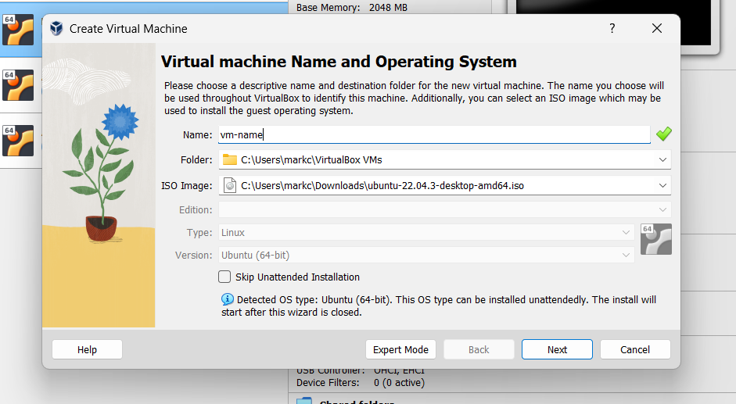

Then hit next to go to the next window. Then hit next and make sure the guest additions box is not ticked like so 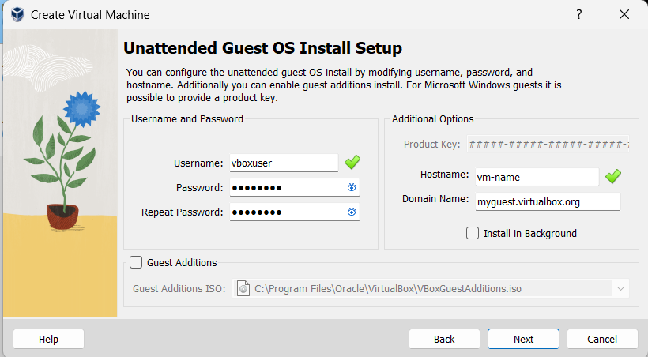

I would recommend allocating this many resources to the VM
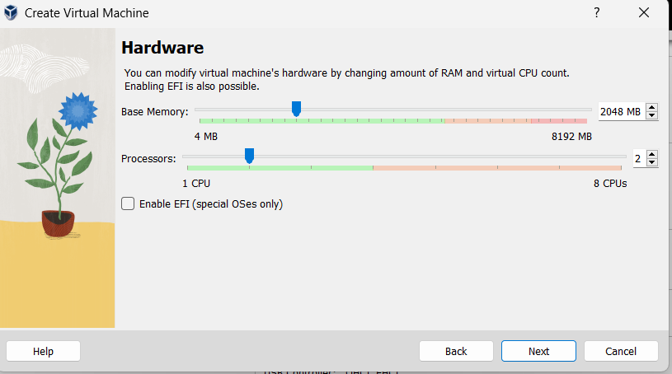

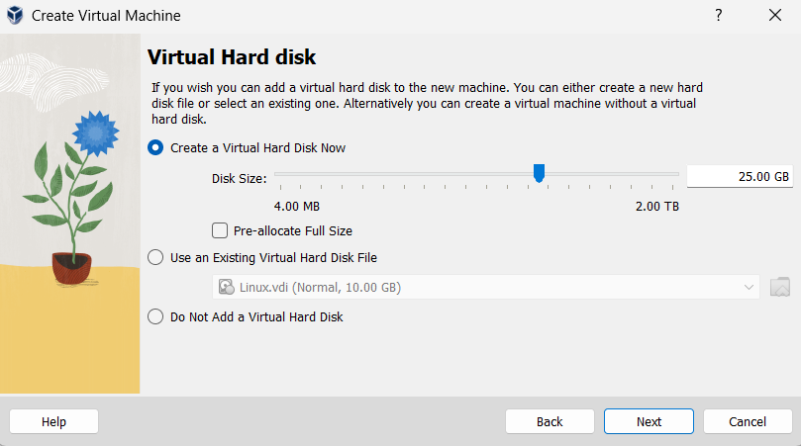

Then this will allow you to finish setting up the VM but before you start the VM go into the VMs settings and disable the network interfaces like so.
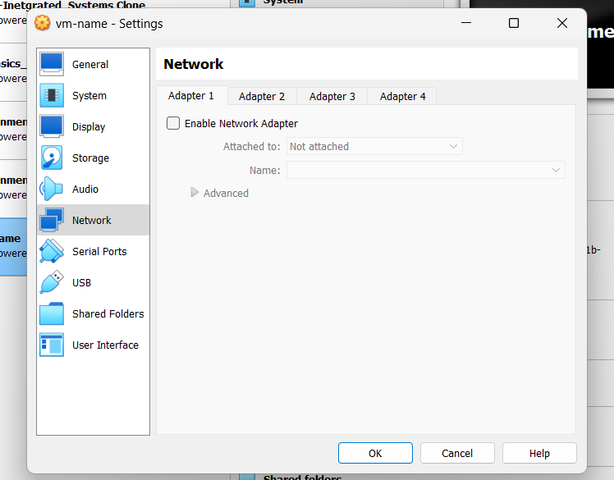

Then start the VM. This should then start to install all the necessary files that the VM will need just let that run to completion. It should look something like this

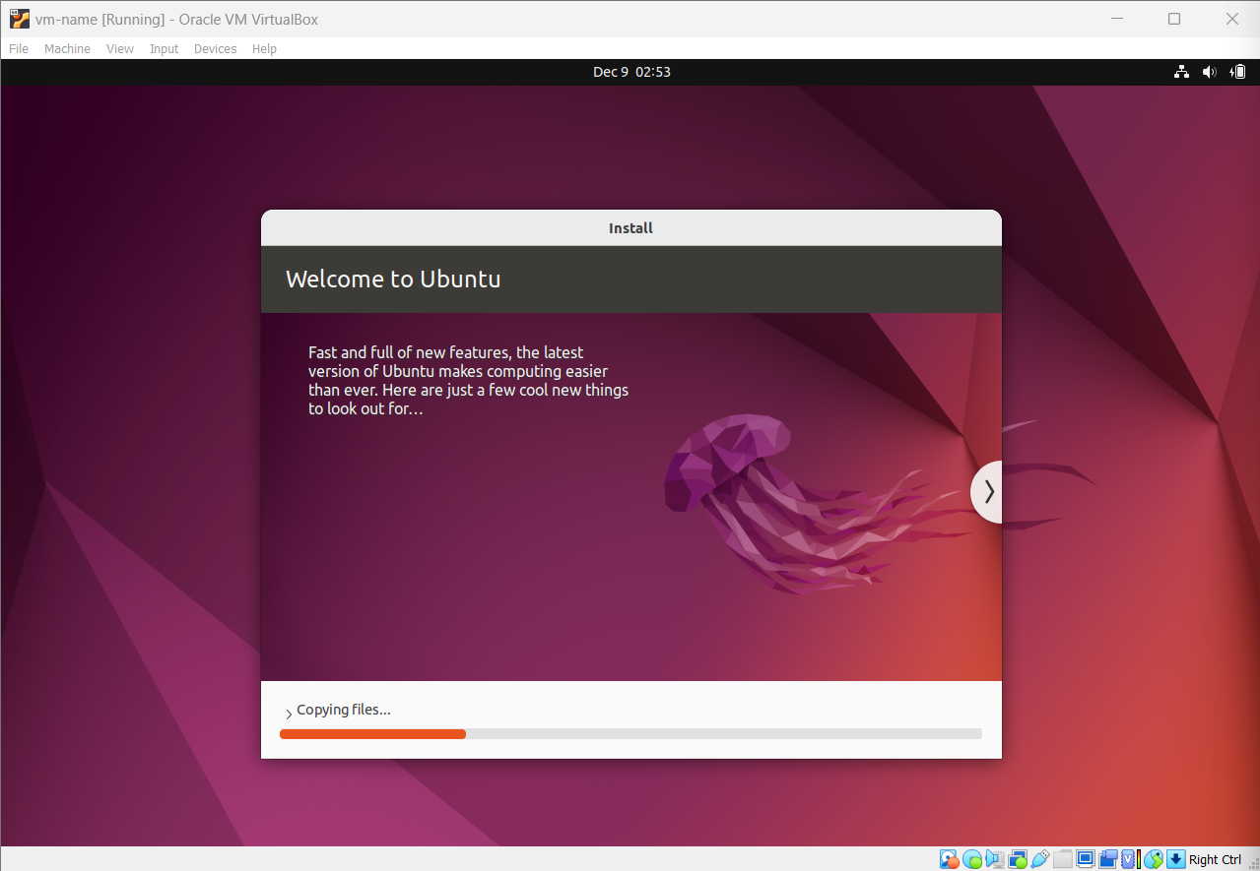

This should then restart the VM once all those downloads and processes are done. Then the VM should be set up appropriately this will allow you to now login and all should be fine.

Task 2:
Q1. I run the command ./vol24 -f ../xp-laptop-2005-06-25.img imageinfo
This provides the answer that the RAM capture was taken at 2005-06-25 16:58:47 UTC000
And the Profile needed to work volatility is WinXPSP2x86

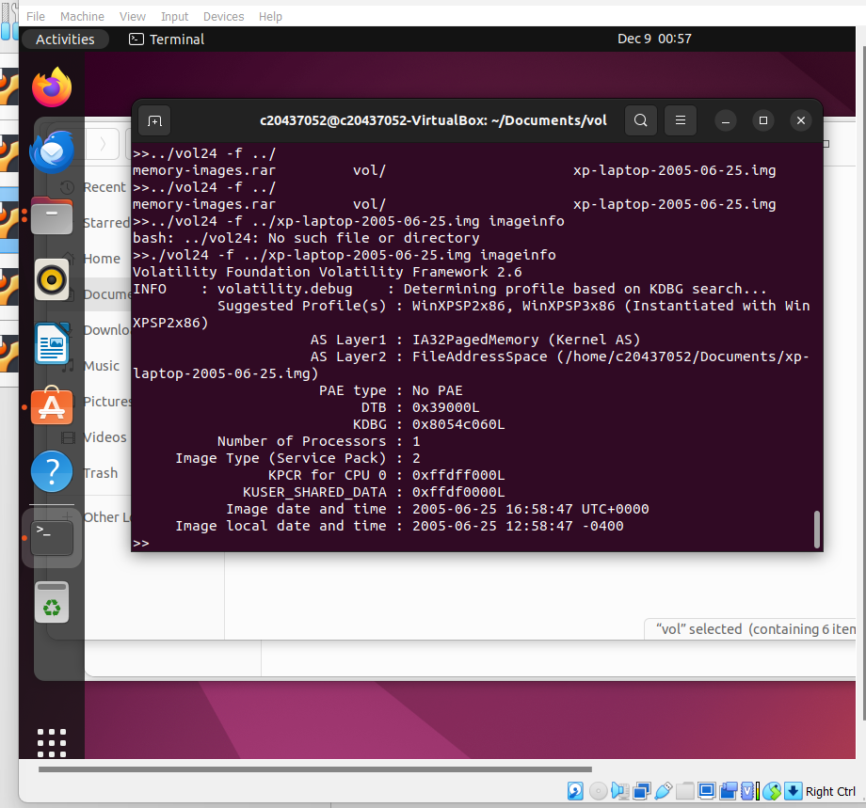

Q2. The command run is command ./vol24 -f ../xp-laptop-2005-06-25.img psxview
This command shows the processes running and any with FALSE in the first column are hidden tasks
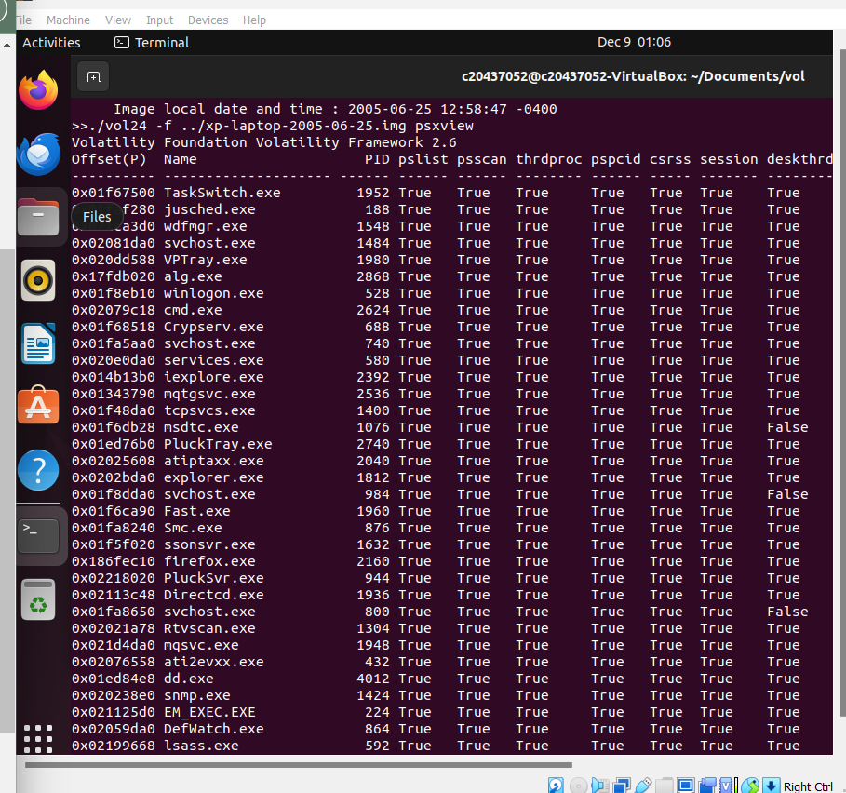
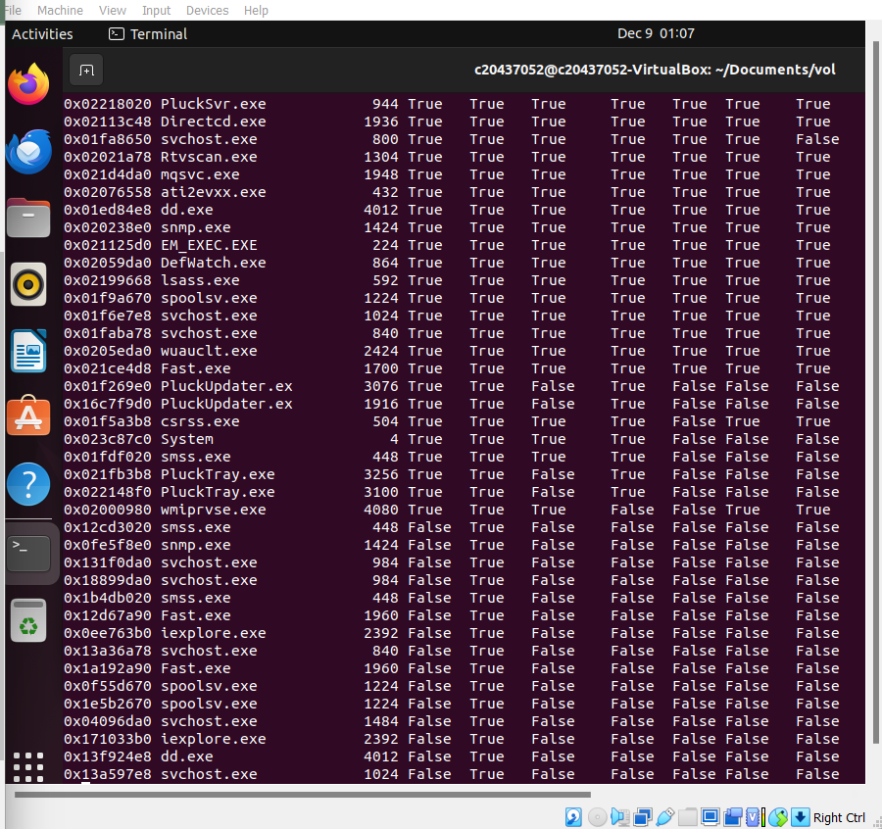
Q3. The command run is command ./vol24 -f ../xp-laptop-2005-06-25.img connscan
This will show all of the TCP connections thus showing the web browsers connected

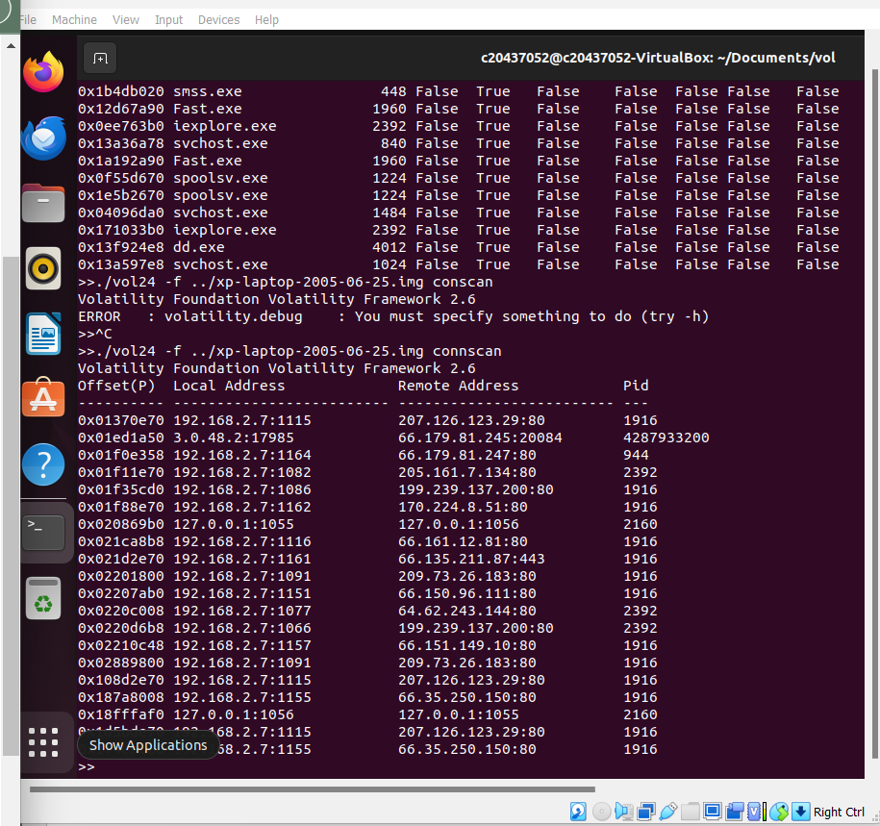

Q4. Command run is ./vol24 -f ../xp-laptop-2005-06-25.img dllist | grep -i ' D:\\'
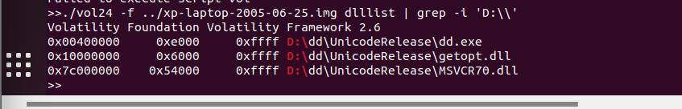

Q5. The command run is command ./vol24 -f ../xp-laptop-2005-06-25.img hashdump
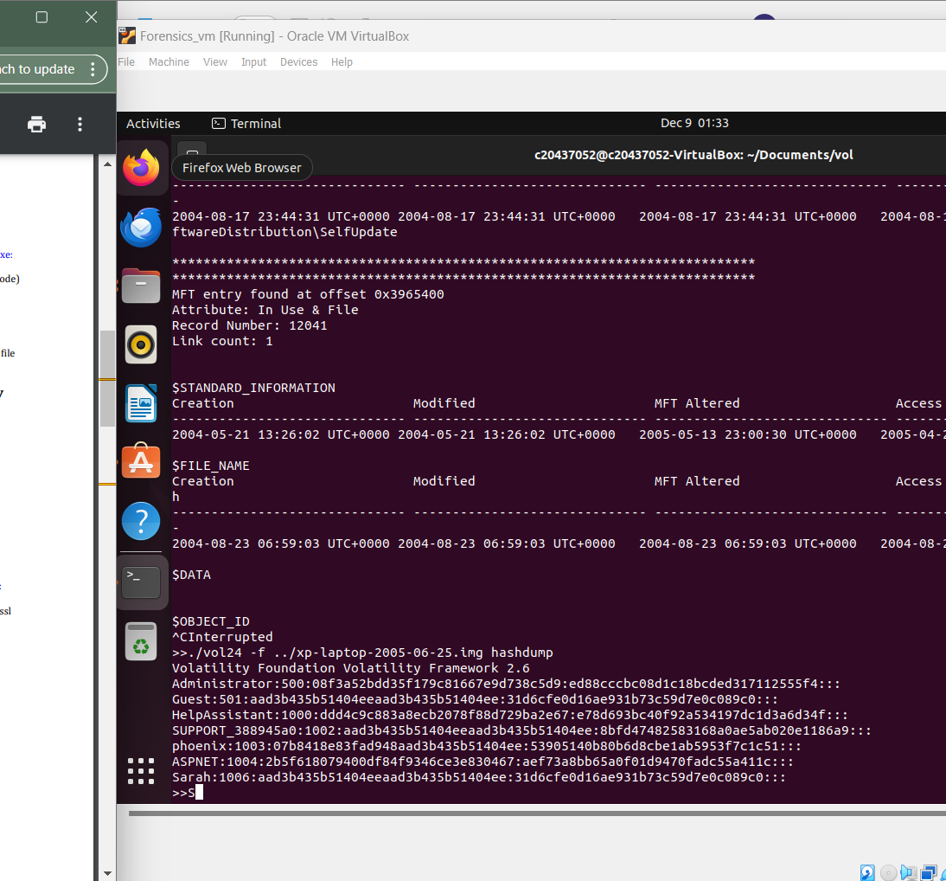

Q6. The command run was
./vol24 -f ../xp-laptop-2005-06-25.img handles | grep -c "File"
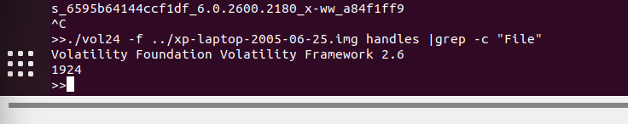

Q7. The command is ./vol24 -f ../xp-laptop-2005-06-25.img handles | grep -c ".\gif"

This command will count all the gifs that are open the amount is 0
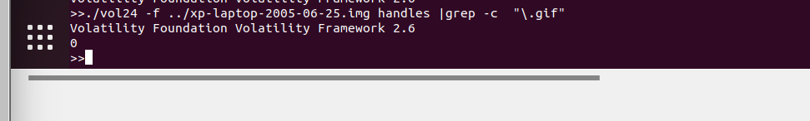
Then to display all the gifs file locations run ./vol24 -f ../xp-laptop-2005-06-25.img filescan | grep -i "/.gif"
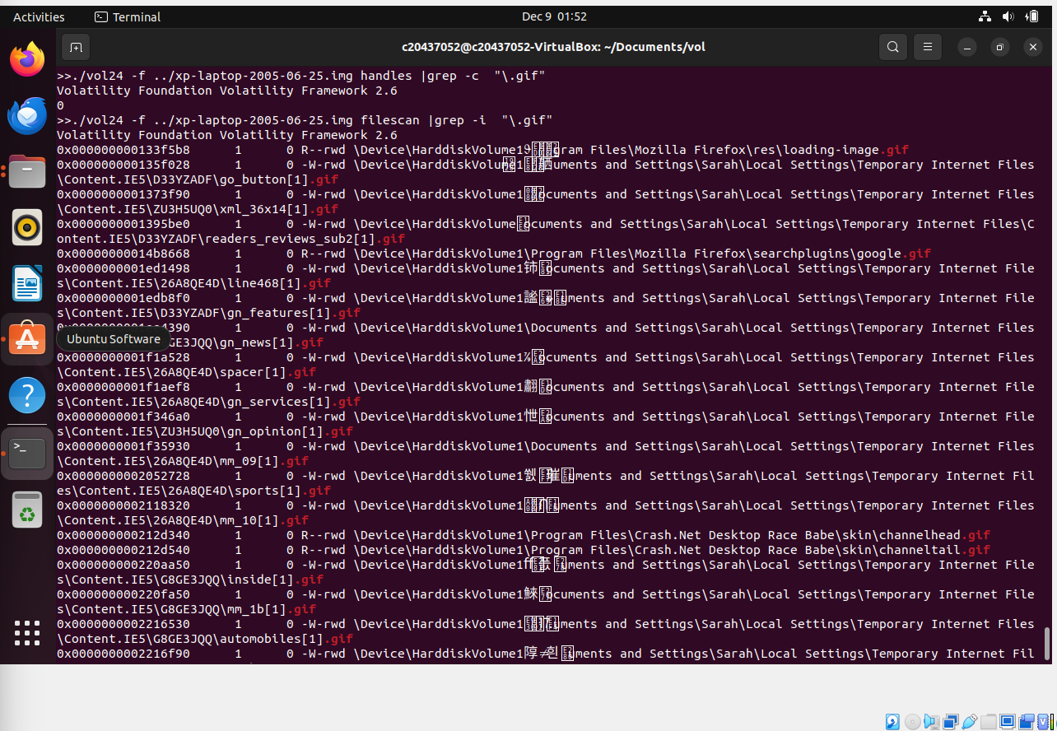

Q8. The command run was ./vol24 -f ../xp-laptop-2005-06-25.img cmdscan
